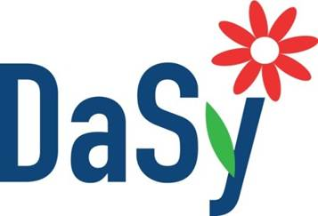
Stakeholder Engagement
Stakeholder Engagement Techniques
There are many options to engage stakeholders in data systems work. Leaders must think about the type of stakeholder input needed, stakeholder characteristics and capacity of the state staff for stakeholder engagement activities when selecting strategies for engagement. The following table offers suggestions of the types of strategies that may work well based on characteristics of the stakeholder engagement process at hand.
This chart will help with the first page of the Identifying Engagement Strategies worksheet.
 | Group Meetings |  | One-on-One Meetings |  | Surveys
 | In-person | Virtual | In-Person | Virtual | N/A
Short time frame
Limited budget
Dispersed geographics
Differing perspectives
Lack of existing relationships
Limited stakeholder availability
Many potential stakeholders
Limited familiarity with data systems work
Data systems work is complex

Strategy well-suited Strategy somewhat Strategy not
well-suited well-suited

Stakeholder Engagement Techniques
Within the categories of group meetings, one-on-one meetings and surveys, there are many different options for how stakeholder input is collected and shared.
This chart will help with the second page of the Identifying Engagement Strategies worksheet.

Suggestions
- Make sure to ask about stakeholder preferences for engagement; this information is critical to the planful selection of strategies.
- Remember that not every stakeholder has to be engaged in the same ways.
- A leadership team meeting may be the best venue to discuss and decide upon stakeholder engagement strategies.
- This information may be captured on a formal stakeholder engagement plan, or in a less formal mechanism. It is recommended that whether using a formal plan or not, decisions about stakeholders and engagement strategies be somehow documented, and reviewed periodically to ensure strategies remain appropriate for the situation and the individual stakeholder.

Resource – Adapted from:
Preskill, H. & Jones, N. (2009). A Practical Guide for Engaging Stakeholders in Developing Evaluation Questions. Robert Wood Johnson Foundation, Princeton, NJ. Retrieved from http://www.rwjf.org/pr/product.jsp?id=49951

